**Question:** How can you cross the Atlantic Ocean with a machine gun jetpack?

**Free Body Diagram:**

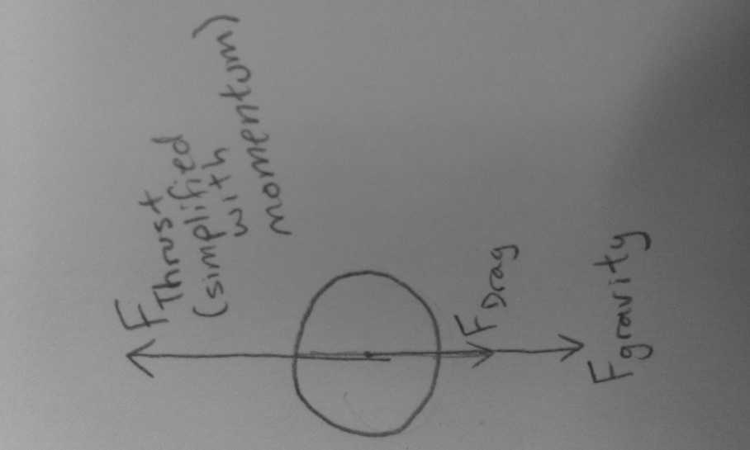

**Equations of Motion:**

Velocity gained from a single bullet firing:

V­Thrust = (-mbullet*Vbullet at muzzle) / Mgun

Acceleration between firings:

a = -9.8

(Currently only using gravity, soon to include drag)

Mass lost by firing is the mass of the whole round, not just the bullet; however, only the bullet is imparted a velocity which affects the momentum of the system.

**Graphs:**

